STARR INTERNATIONAL INSURANCE (SINGAPORE) PTE. LTD.

Public Disclosure

in accordance with MAS Notice 124

For the Financial Year Ended 31 December 2025

Contents
1. Company Profile 1
2. Key Business Segments, Products, Objectives & Strategies 1
2.1 Accident & Health 1
2.2 Casualty 1
2.3 Financial Lines 1
2.4 Construction 2
2.5 Technical Risk (Tech) 2
2.6 Marine 2
3. Corporate Governance Framework 2
4. Internal Controls & Risk Management 3
5. Enterprise Risk Management Framework 3
5.1 Enterprise Risk Management (“ERM”) Committee 4
5.2 Working Groups of the ERM Committee 4
5.3 Asset-Liability Management (“ALM”) 4
6. Changes in material accounting policies 5
7. Technical Provisions 5
8. Capital Adequacy 6
9. Financial Instruments & Investments 7
9.1 Investment objectives 7
9.2 Investment policies & procedures 7
9.3 Financial assets 7
10. Financial Performance 7
11. Insurance and Financial Risk Management 8
11.1 Underwriting risk 8
11.2 Reinsurance strategy 8
11.3 Concentration risk 9
11.4 Product features 9
11.5 Credit risk 9
11.6 Liquidity risk 10
11.7 Market risk 10
11.8 Interest rate risk 11
11.9 Foreign currency risk 11

Company Profile

Starr International Insurance (Singapore) Pte. Ltd. (“Starr Singapore”/”Company”), a non-life insurance company organized under the laws of Singapore, is a wholly owned subsidiary of Starr Insurance & Reinsurance Limited, an insurance and reinsurance company organized under the laws of Bermuda. Starr Insurance & Reinsurance Limited is an indirect, wholly owned subsidiary of Starr International Company, Inc. (“Starr International”), a company organized under the laws of Switzerland.

The Company has established overseas branches in (i) Labuan, Malaysia, which was granted an insurance license in February 2023(the “Labuan Branch”)., (ii) in South Korea, which was granted an insurance license in October 2024 (the “Korea Branch”)., and (iii) in GIFT City, India, which was granted an insurance license in September 2025 (the “IFSC Branch”).

Key Business Segments, Products, Objectives & Strategies

Starr Singapore’s overall strategic objective is to generate sustained profitability of its insurance carriers, while maximizing capital efficiency. This is achieved through a well-maintained governance and control environment, where the organization’s risk profile is commensurate to the risk appetite of senior management.

2.1 Accident & Health
- Responsive to Travel consumer market’s needs with updated strategies for different distribution channels
- Continue to expand electronic platforms to facilitate online selling, tapping into potential markets and enhance cost efficiency and effectiveness
- Continue to build, and expand relationships with potential partners with extensive networks

2.2 Casualty
- Partner with Technical Risks, Construction, Energy and Industrial Risk business areas to leverage opportunities
- Add new products and offerings
- Expand our broker base by accentuating our deep market knowledge and our global presence
- Regional line of business specialists designing products and strategies in each market

2.3 Financial Lines
- Increase use of strategic partnerships by continuing to expand participation on key broker panels
- Maintain diversification of products and industries
- Increase lead positions by utilizing our technical expertise and underwriting capabilities
- Focus marketing and development efforts in underserved regions and markets
- Explore and develop new products

2.4 Construction
- Continue to focus on high level renewal strategy
- Lead and control business by utilizing larger lines with use of quality facultative support
- Continue to build on existing large producer contacts and create new relationships with smaller producers
- Market our competitive advantage such as our capability to provide comprehensive coverage including terrorism and Starr’s casualty capabilities

2.5 Technical Risk (Tech)
- Increase lead positions by promoting Starr Tech’s loss control expertise
- Improve penetration in selected international regions
- Ongoing participation on integrated energy packages
- Utilize the increased capacity to lead more business and minimize clash issues
- Leverage Starr’s existing positions in construction and global energy packages to generate new opportunities

2.6 Marine
- Continue to develop existing client relationships
- Continue to promote products that differentiate Starr Singapore from the market
- Increase market penetration into selected geographical regions
- Focus on the transportation sector with emphasis on large ports, terminals, stevedores, ship owners and similar industries

Corporate Governance Framework

Starr Singapore’s Board of Directors (the “Starr Singapore Board”) is responsible for overseeing all aspects of the operations, including matters of corporate governance. The Starr Singapore Board holds quarterly meetings and is comprised of five members, a majority of which are independent directors, including a non-executive Chairman. The Starr Singapore Board reviews the underwriting, investments, operations, financial, compliance and risk management and reinsurance matters of Starr Singapore. During these quarterly meetings, updates on risk management activities, including issues or emerging topics of strategic, operational, financial and capital risk relevance are discussed, evaluated and follow-up action plans are developed as appropriate. The Board is also responsible for assessing its own effectiveness and independent directors’ independence, for identifying candidates and reviewing nominations for the appointment of directors, board committee members, the appointed actuary, and executive officers of Starr Singapore, and for reviewing the Company’s remuneration policy.

The Board is supported by an Audit Committee and an Investment Committee, and is assisted by a Senior Management Committee in the operational management of the Company. The Audit Committee notably includes one non-executive director and all three independent directors (comprising the majority of the Starr Singapore Board), and is responsible for the adequacy of the external and internal audit functions. The Investment Committee notably includes the Chief Executive Officer and Chief Investment Officer of the Company, and is responsible for overseeing the Company’s investment activities. Members of the Senior Management Committee represent general management, underwriting, claims, finance, legal and compliance, risk management, information technology and human resources. The Board has also established a Labuan Branch Committee, a Korea Branch Committee and an IFSC Branch Committee to oversee the operations of its Labuan, Korea and IFSC Branches, respectively.

The Chairman and the Chief Executive Officer positions are held by different persons.

Internal Controls & Risk Management

It is the policy of Starr Singapore to maintain effective systems and controls to provide reasonable assurance to promote performance leading to effective accomplishment of business objectives and goals, safeguard assets, provide accurate and reliable and other key data, promote operational efficiency and economy, and encourage adherence to applicable laws, regulations, policies and practices.

Internal control consists of five interrelated components, including control environment, risk assessment, control activities, information and communication, and monitoring. Control environment sets the tone of the Company, and provides discipline and structure. The Company has developed a risk management framework for the business which continues to be embedded into its operational structure. Control activities, including preventative, detective and assurance, are the policies and procedures that help ensure management directives are carried out. Pertinent management information is then identified, captured and communicated in a form and timeframe that enables employees to carry out their responsibilities. Information systems produce reports, containing operational, financial and compliance-related information, that make it possible to control the business. At the end, internal control systems need to be monitored, a process that assesses the quality of the system’s performance over time. This is accomplished through ongoing monitoring activities, separate evaluations or a combination of the two.

Starr Singapore’s Board of Directors provides governance, guidance and oversight. The Board also ensures that the Company’s day-to-day operations are in the hands of qualified, honest and competent management. The CEO of the Company is ultimately responsible and assumes ownership of the internal control policy and framework. Senior managers, in turn, assign responsibility for establishment of more specific internal control policies and procedures to staff within their team. Internal audits are a key element in monitoring and assessing the integrity of internal controls and the internal control environment. Internal auditors play an important role in evaluating the effectiveness of control systems, and contribute to ongoing effectiveness. Nevertheless, internal control is, to some degree, the responsibility of every employee of the Company. All employees are responsible for communicating upward challenges in operations, non-compliance with the Company’s Code of Conduct, or other policy and procedural failures or illegal actions.

Enterprise Risk Management Framework

Starr International has established an ERM program to ensure that true active risk management is built into daily business operations through traditional risk management and operational risk management throughout the organization. Starr International’s leadership believes that strong risk management practices and a sound internal control environment are fundamental to its success and profitable growth. Starr International’s ERM program consists of three main pillars – (i) Framework, (ii) Policies and Procedures; and (iii) Continuous Two-Way Communication.

5.1 Enterprise Risk Management (“ERM”) Committee

An ERM Committee has been established by the Board of Directors (“Board”) of Starr Insurance Holdings, Inc (“Starr Insurance”), a fully-owned indirect subsidiary of Starr International, to monitor and govern any emerging risk issues associated with the organization’s insurance activities and its investment portfolio and oversee the organization’s ERM programs and policies, including risks relating to business and financial strategies, operations, compliance, reputation and ethics and cyber security.

The ERM Committee has developed and established processes, procedures and reviews that encompass the risk management of all of Starr International’s insurance company subsidiaries.

The duties of the ERM Committee of Starr Insurance include, but are not limited to:
- Review portfolio qualitative analyses and sectoral qualitative analyses to assess overall insurance portfolio;
- Monitor risk-based capital adequacy measures and trends over time;
- Review reserve level adequacy;
- Review market risk measures and management;
- Review emerging regulatory, market, accounting and other trends or developments with significant risk implications;
- Review new risk management initiatives; and
- Perform such other duties as may be delegated to it or requested by the Board.

5.2 Working Groups of the ERM Committee

The ERM Committee of Starr Insurance has established the ERM Working Group, the Global Underwriting Working Group and the Data Privacy and Information Security Working Group, which meet periodically to review ongoing projects and report directly to the ERM Committee. These working groups are composed of individuals with various backgrounds and areas of expertise within the insurance industry. The ERM Working Group reports quarterly to the ERM Committee of Starr Insurance, or as soon as possible thereafter.

At the local or country level, the ERM structure and responsibilities mirror the group level structure with modifications suitable for the nature, scale and complexity of the local subsidiary company’s activities. Materials for the quarterly report are also provided by the Data Privacy and Information Security Working Group with regard to threats and risks associated with privacy and cyber-security.

5.3 Asset-Liability Management (“ALM”)

The Company’s asset-liability management policy is intended to recognize the interdependence between the assets and liabilities of the Company, and takes into account any correlations of risks between different asset classes and any correlations between different products and business lines. The Company’s investment policy is designed to ensure that the Company has sufficient cash or easily recognized assets to meet its liabilities as they fall due.

Changes in material accounting policies

The Company has has adopted all new and revised Financial Reporting Standards in Singapore (“FRS”) that are effective for the annual period beginning on 1 January 2025.

The adoption of these standards did not result in any material changes to the Company’s accounting policies or have a material impact on the financial performance or position of the Company.

Technical Provisions

Technical provisions include provision for claims liabilities and provision for premium liabilities. The valuation of technical provisions is conducted in accordance with MAS Notice 133 – “Notice on Valuation and Capital Framework for Insurers” issued by the Monetary Authority of Singapore (“MAS”).

Claims liabilities
The assumptions used in the estimation of insurance assets and liabilities are intended to result in provisions which are sufficient to cover any liabilities arising out of insurance contracts so far as can reasonably be foreseen.

However, given the uncertainty in establishing a provision for claims liabilities, it is likely that the final outcome will prove to be different from the original liability established.

Provision is made for the expected ultimate cost of all reported and unreported claims, together with related claims handling expenses, less amounts already paid.

The data used for determining the expected ultimate claim liabilities is collated internally based on business underwritten by the Company. This is further supplemented by externally available information on industry statistics and trends.

The Company’s reserving methodology is intended to result in the most likely or expected outcome for the ultimate loss settlement for each type and class of business by analyzing the historical claim payments to identify possible trends in order to project future claim payments. The Company also considers the nature of the risks underwritten, geographical location, sum insured, and previous experience to estimate expected ultimate losses for each class of business and accident year. The derived expected ultimate loss ratios are internally checked to ensure that they are consistent with observable market trends or other market information, as considered necessary. Where there is insufficient information the expected ultimate claim liabilities are based on prudent assumptions.

The Company systematically and periodically reviews the provisions established and adjusts the loss estimation process in an effort to reduce the variance between the actual outcome and projections.

Provisions for insurance claims are assessed by the approved actuary in accordance with local insurance regulatory requirements. The actuary used paid and incurred loss development methods, the expected loss ratio method, and the Bornhuetter-Ferguson ("BF") method, to estimate the gross and net claims liabilities.

The paid and incurred loss development methods are based upon the assumption that the relative change in a given accident year's paid/incurred loss from one evaluation point to the next is similar to the relative change in prior accident years' paid/incurred loss at similar evaluation points. Since the loss development assumptions based on the Company’s limited historical experience are not fully credible, the actuary supplemented with benchmark loss development assumptions.

The expected loss ratios are selected based on benchmarks of similar risk profile in the Singapore insurance market. The benchmark figures are drawn upon statistics and information available from both internal and external sources. They are revised periodically as new information and trends emerge.

The BF method relies on a gradual transition from an expected loss ratio to an experience-related development. It is applied to the more recent accident years, for which the paid and incurred loss development methods may yield less accurate results. The expected loss ratios were selected based on the projected ultimate loss ratios for all historical years for which the premium information is available and benchmarks of similar risk profile in the Singapore insurance market.

An additional loading is applied, otherwise known as a provision for adverse deviation (“PAD”). A provision for PAD as directed by MAS, is included relating to the inherent uncertainty in the best estimate value of claims and premium liabilities at a minimum 75% level of sufficiency.

Premium liabilities
The methodology for determining premium liabilities is as follows:

- the unearned premiums for each class of business is multiplied by the expected ultimate loss ratios and maintenance expense ratios for each class of business to arrive at the best estimate of the Unexpired Risk Reserve (“URR”);
- the URR is then further loaded with a PAD margin to provide a 75% probability of sufficiency, after allowing for the effects of diversification on a fund by fund basis; and
- this URR with PAD is then compared to the Company’s held unearned premiums reserve net of deferred acquisition cost, and the higher of the two is the final provision for premium liabilities.

Capital Adequacy

All insurers that carry on insurance business in Singapore are registered with MAS and are subject to the prudential standards which set out the basis of calculating the fund solvency requirements (FSR) and the capital adequacy requirements (CAR), which is a minimal level of capital that must be held to meet policyholders’ obligations. The FSR and CAR apply a risk-based approach to capital adequacy and are determined to be the sum of aggregate of the total risk requirement of all the insurance funds established and maintained by the insurer under the Insurance Act 1966 (the “Insurance Act”). It is the Company’s policy to hold capital levels in excess of FSR and CAR. As at 31 December 2025, the Company’s capital adequacy ratio was 342%. The Company has compiled with all externally imposed capital requirements.

Financial Instruments & Investments

9.1 Investment objectives

The prime investment objective is capital reservation in order not to affect the Company’s underwriting capacity. The secondary objective is to provide a moderate rate of return through a diversified portfolio of investments that meets the return objective.

9.2 Investment policies & procedures

The Company has in place an Investment Policy which provides for the governance, risk management, investment objective, return objective, liquidity, risk guidelines, permitted securities, prohibited assets and excluded transactions, asset allocation, credit criteria, custodian, investment authority, reporting, etc. of the Company’s investments.

9.3 Financial assets

The Company recognizes deposits with financial institutions on the date on which they are originated. All other financial instruments are recognized on the trade date, which is the date on which the Company becomes a party to the contractual provisions of the instrument.

A financial asset is measured at fair value. The fair value of corporate bonds is based on quoted market prices as the reporting date. The carrying amounts of other financial assets with a maturity of less than one year (including insurance and other receivables and cash at bank) are assumed to approximate their fair values due to the short period to maturity.

The Company derecognizes a financial asset when the contractual rights to the cash flows from the asset expire, or it transfers the rights to receive the contractual cash flows in a transaction in which substantially all the risks and rewards of ownership of the financial asset are transferred or in which the Company neither transfers nor retains substantially all of the risks and rewards of ownership and it does not retain control of the financial asset.

Financial Performance

For the financial year ended 31 December 2025, the Company’s insurance revenue amounted to about USD424 million, representing a growth of about 2% comparing to the previous year. Insurance service result for 2025 was around USD 44 million, similar to the result of the previous year. The Company has been operating at a profit for the past five (5) years.

Insurance and Financial Risk Management

The Company is exposed to a variety of insurance and financial risks in the normal course of its business activities. These include principally underwriting, concentration risks, liquidity and market risks, credit, interest rate and currency risks. Management is guided by risk management policies and guidelines set by the immediate holding company as part and parcel of its overall business strategy and philosophy. To facilitate the task of monitoring these exposures, established processes are put in place by the immediate holding company.

Underwriting risk

Underwriting risk includes the risk of incurring higher claims costs than expected owing to the random nature of claims and their frequency and severity and the risk of change in legal or economic conditions or behavioural patterns affecting insurance pricing and conditions of insurance or reinsurance cover. The Company seeks to minimise underwriting risk with a balanced mix and spread of business between classes of business and by observing underwriting guidelines and limits, prudent estimation of the claims provisions, and high standards applied to the security of reinsurers.

The underwriting strategy is included in the strategic business plan that sets out the classes of business to be written and the industry sectors to which the Company is prepared to expose itself. The strategy is communicated down to individual underwriters through detailed underwriting guidelines and authorities that set out the limits that any one underwriter can write by line size, class of business and industry in order to enforce appropriate risk selection within the portfolio.

Sensitivity analysis

The table below analyses how the profit or loss and equity would have increased (decreased) if changes in underwriting risk variables that were reasonably possible at the reporting date had occurred. This analysis presents the sensitivities both before and after risk mitigation by reinsurance and assumes that all other variables remain constant.

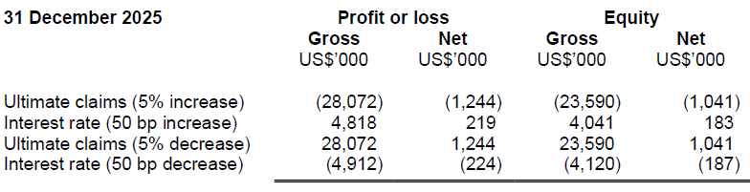

Reinsurance strategy

The Company reinsures a portion of the risks it underwrites in order to control its exposures to losses and protect capital resources. This is done through proportional and nonproportional reinsurance outwards treaties from reinsurers. In addition, the Company also reinsure through facultative reinsurance.Concentration risk

Concentration limits are set to avoid heavy concentration within a specific industry or country. There is regular monitoring and reporting of any heavy concentration of risk exposure towards any industry, country and client limits.

Product features

The business portfolio of the Company is largely short-tailed with the major class being property.

Credit risk

Credit risk is the risk of financial loss to the Company if a customer or counterparty to a financial instrument fails to meet its contractual obligations.

Management has a credit policy in place and the exposure to credit risk is monitored on an ongoing basis. Credit evaluations are performed on all customers requiring credit over a certain amount. The Company does not require collateral in respect of financial assets.

At the reporting date, there are no significant concentrations of credit risk. The maximum exposure to credit risk is represented by the carrying amount of each financial asset in the statement of financial position.

The table below provides information regarding the credit risk exposure of the Company as at the reporting date by classifying the fixed income securities and cash and fixed deposits according to credit ratings of the counterparties which are based on S&P’s financial strength rating or its equivalent. The fixed income investments are assessed using stringent investment criterion which include, but are not limited to, a thorough analysis of each debt security’s terms and conditions, the availability and quality of the guarantor, as well as financial strength of the issuer.

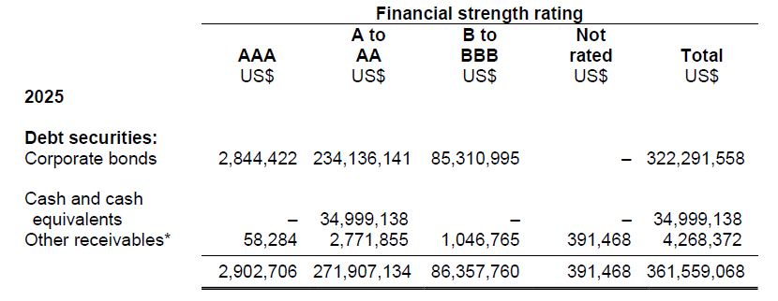
* Excludes prepayments and GST recoverable

The carrying amount of reinsurance contract assets is made up by 99% of balances rated A to AA and 1% of balances not rated.

Liquidity risk

Liquidity risk is the risk that the Company will encounter difficulties in meeting obligations associated with financial instruments. The Company has to meet its liabilities as and when they fall due, notably from claims arising from its general insurance contracts. There is therefore a risk that the cash and cash equivalents held will not be sufficient to meet its liabilities when they become due. The Company manages this risk by setting minimum limits on the maturing assets that will be available to settle these short-term liabilities.

The nature of insurance business is that the requirements of funding cannot be predicted
with absolute certainty as the theory of probability is applied on insurance contracts to
ascertain the likely provision and the time period when such liabilities will be settled. The amounts and maturities in respect of insurance contracts provision are thus based on the Management’s best estimate and past experience.

The following table provides a maturity analysis of the Company’s insurance contracts, which reflects the dates on which the cashflows are expected to occur. Liabilities for remaining coverage measured under the PAA have been excluded from this analysis.

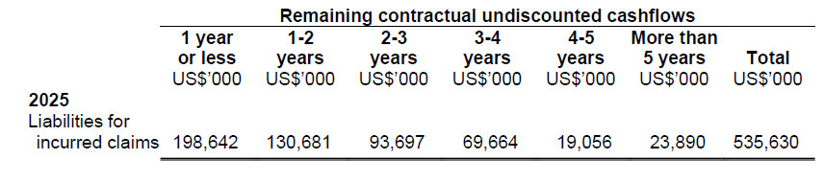

The table below summarises the maturity profile of other liabilities of the Company based on the remaining undiscounted estimated obligations at the reporting date.

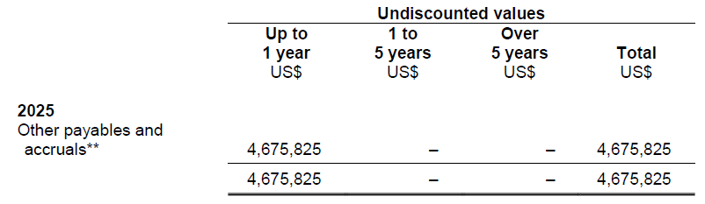
** Excludes accrued staff benefits and asset retirement provision

Market risk

Market risk is the risk that changes in market prices, such as interest rates, foreign exchange rates and equity prices will affect the Company’s income or the value of its holdings of financial instruments. The objective of market risk management is to manage and control market risk exposures within acceptable parameters, while optimising the return on risk.

At the reporting date, the Company does not have any significant exposure to equity price risks.

Interest rate risk

The Company’s exposure to changes in interest rates relates primarily to interest-earning financial assets. The Company does not use derivative financial instruments to hedge its interest rate risks.

The table below summarises the effective interest rates at the reporting date for interest-bearing assets together with the contractual maturity dates of these assets.

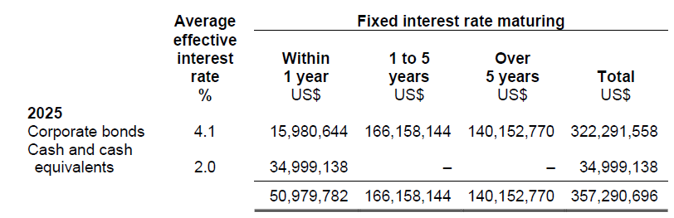

Sensitivity analysis

The Company does not account for any fixed rate financial assets and liabilities at fair value through profit or loss, therefore a change in interest rates at the reporting date would not affect profit or loss.

Foreign currency risk

The Company is exposed to the effects of foreign exchange rate fluctuations primarily
because of its foreign currency denominated underwriting revenues and expenses. Foreign currency denominated assets and liabilities, together with firm and probable purchase and sale commitments give rise to foreign exchange exposure. Exposure to foreign currency risks are monitored on an ongoing basis.

The Company does not use derivative financial instruments to hedge its foreign currency risks.

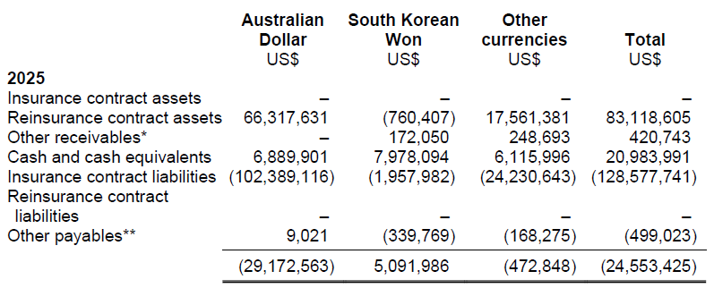
* Excludes prepayments and GST recoverable
** Excludes accrued staff benefits and asset retirement provision

Sensitivity analysis
A 10% strengthening of United States dollar against the following currencies at the reporting date would increase/(decrease) profit or loss by the amounts shown below. This analysis assumes that all other variables, in particular interest rates, remain constant.
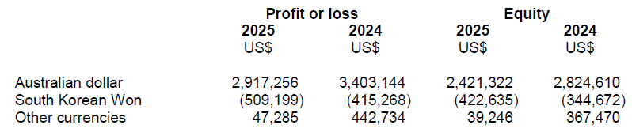
A 10% weakening of United States dollar against the above currencies would have the equal but opposite effect on the above currencies to the amounts shown above, on the basis that all other variables remain constant.

